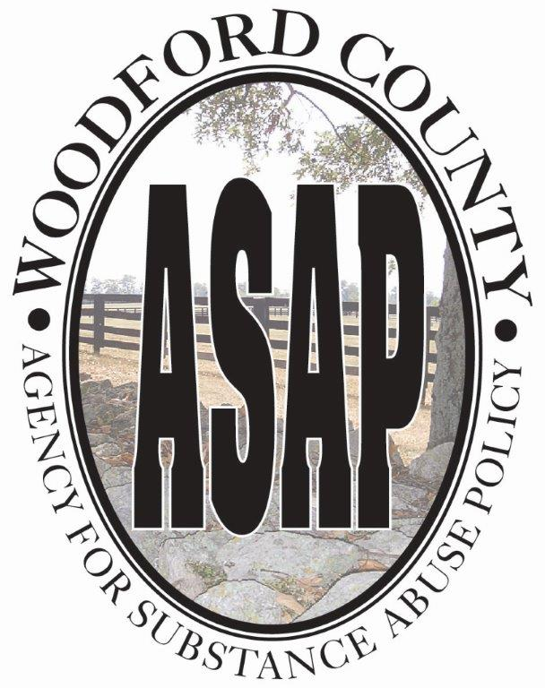

Woodford County ASAP Board
January 17, 2023
AGENDA
The mission of the Local Board is to develop a long-term strategy that is designed to reduce the occurrence of
Youth and adult alcohol, tobacco and other drug use and addiction by the implementation of prevention,
Intervention and treatment strategies.
website: www.drugfreewoodford.com

Welcome/Introductions Freeman Bailey, Chair

Approval of Minutes Freeman Bailey
Presentations:
Ky. Opioid Abatement W. Bryan Hubbard, Chair &
Advisory Commission Executive Director
Advisory Commission
Ky. Office of Attorney General

Brief update WC Planet Youth Model Lisa Johnson

Monthly Budgets Update: Nancy Blackford
2022-2023 ASAP General
Harm/Reduction
2023-2024 New applications for ASAP & Harm Reductions are due January 30, 2023

Announcements – “Around the Table” Freeman Bailey
(Members are asked to send a short-typed paragraph to Nancy Blackford by email (nblackford.asap@gmail.com) or text 859-
351-2594 for inclusion in the minutes.)

Next ASAP meeting – March 21, 2023
Place-EMS Conference Rm, Big Sink, Versailles, Ky.
Adjourn

