Woodford County ASAP Board Meeting Minutes
Location: Woodford County Emergency Medical Services

Date: July 19, 2022
Start time: 8:30
End time: 9:30

Chair: Freeman Bailey, WC ASAP Chair
Agenda Attached: Yes
Next meeting: September 20, 2022 at EMS Conference Room, Big Sink, Versailles, KY 40383

Present:
Permanent Voting Members | Non-Permanent Voting Members | Non-Voting Members / Guests
- WCHD Director Cassie Prather  - New Vista, DeShawn Freeman  - WCHS Family Resource Center Director Jasmine Hazelwood  Absent:  Judge Exec. James Kay  DCBS-Julie Snawder | - EMS Director and Mental Health Commissioner, Freeman Bailey, Chair  - M & M Director, Lisa Johnson  - Versailles Police Department, Rob Young  - UK Cooperative Extension Office, Elizabeth Coots  - Woodford County Attorney, Alan George  - WC Sheriff’s Department, Jimmy Fugate  - WC Casa Coordinator, Jeanne Box  - Serenitee, Sephanie M. Raglin | - ASAP Coordinator, Nancy Blackford  - Woodford County Magistrate, Larry Blackford  - WCHD Grants & Data Manager Robin Miller  - WCMS Family Resource Center Director, Mallory White  - WCPS FRC, Ashley Hicks  - New Vista, Aaron Foley  - Isaiah House, Ariel Appling  - Bourbon, Scott, Woodford Drug Court, Evanne Cornette

Welcome and Introductions
ASAP Chair Freeman Bailey: Members and guests welcomed, and introductions were made.

Approval of Minutes
Freeman Bailey asked for a motion to approve the minutes from the May 3, 2022, meeting.
Motion to approve the minutes: Lisa Johnson
Motion second: Rob Young
Motion approved
Presentations
Reverend Stephanie Raglin
Serenitee At Its Best

Reverend Raglin came home to Versailles to minister to the needs of folks struggling with drugs and alcohol and to give back to the community. Substance use is the result of many other life experiences and mental health issues that underlie addiction. Rev. Raglin has already started working with WCHS and provides individual counseling and group therapy. Her practice is located at 125 Big Sink Suite D in Versailles.
Presentation:
Lisa Johnson
Mentors and Meals

Ms. Johnson provided an update regarding the Planet Youth service contract that was discussed during the Just Say Yes Summit on May 3, 2022. Annual cost will be approximately $28,000 and will be shared by the city of Midway, the city of Versailles, Woodford County, and the Woodford County Health Department to fund the behavioral survey, training, and program implementation guidance provided by Planet Youth. Ms. Johnson reiterated the importance of the survey, emphasizing the fact that it will provide data that is fresh and local. Specific dollar amounts of commitment by Judge Executive James Kay, Mayor Brian Traugott, Mayor Grayson Vandergrift, and the Woodford County Health Department have not been finalized.

Discussion:
Cassie Prather said that the Health Department would match Midway’s contribution and that she looks forward to celebrating this important next step of signing the Planet Youth contract.

Attorney Allen George had a question about how much the county would be paying. Preliminary financial commitments were discussed in the following amounts:

WCHD: $2200 (approximate, per Cassie Prather)
Midway: $2200
ASAP: $3500 (approximate, per Nancy Blackford)
Versailles: TBD
County: TBD

Attorney Allen George also had a question about whether the county’s contribution would be funding implementation of the Just Say Yes program or the Planet Youth contract, adding that he felt it would be best for the county to utilize funds received from the Opioid Settlement to help fund Planet Youth. After some discussion, Lisa Johnson clarified that Just Say Yes program costs would be funded by grants, and that the county’s contribution would help fund the contract with Planet Youth, not costs of the Just Say Yes program.

Nancy Blackford asked about the timeline for receipt of Opioid settlement disbursements. Mr. George responded, saying that he anticipates receiving an installment of approximately $55,000 from the Opioid settlement in late summer.

Freeman Bailey reiterated the need to keep the conversation moving forward and to take next steps to ensure we are proactively addressing the risks to youth in Woodford County. He discussed the importance of timing, given the recent news that the old Kroger is being developed as an indoor recreational facility for children and families. Mr. Bailey liked Cassie Prather’s use of the word “celebrate” and agreed that a celebration would be in order once financial partners were ready to commit the funds and sign the agreement with Planet Youth, a vital first step.

Budgets Update
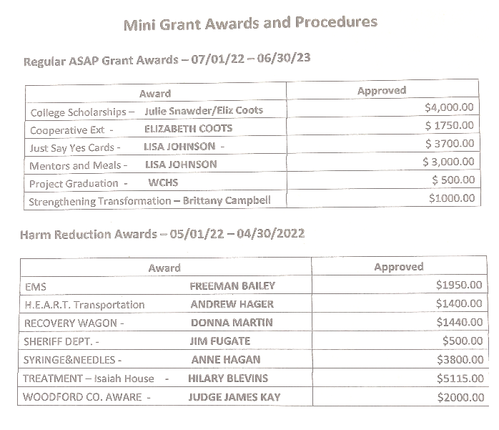
Nancy Blackford
2022-2023 ASAP General / Harm Reduction (see attached)
2021-2022 ASAP General / Harm Reduction (see attached)

Mini-grants (see)
Ms. Blackford announced recipients of
mini-grants awarded by ASAP and asked
recipients to provide reports of activities and
money spent, emphasizing the need to spend the
money for the purposes identified in the initial
grant proposals. Nancy advised contacting
her to discuss any changes that needed to be made to
the way that the money would be utilized.

Lisa Johnson: Requested a clerical change to “Mini grant Awards and Procedures” to indicate “Woodford County Health Department” as the fiscal agent for the Just Say Yes award instead of “Lisa Johnson”. Ms. Blackford agreed to make the change.
There were no further questions regarding budgets.
New Officers
Chair: Freeman Bailey
Vice Chair: Elizabeth Coots
Motion to approve was made by Lisa Johnson
The motion was seconded by Reverend Stephanie Raglin
Motion approved

Announcements- “Around the Table”
- Rob Young, Versailles Police Department: no new announcements
- Cassie Prather, WCHD: New Harm Reduction Specialist, Rolgard Casmir
WCHD will partner with Woodford Aware
- Elizabeth Coots, Announcement of event “Truth and Consequences: The choice is Yours”
via Cooperative Extension with WCMS and WCHS to take place on September 22, 2022. Attendees will have a realistic conversation with adult community partners to learn about the physical, social, and legal consequences of using substances
- Ariel Appling, Isaiah House: Open beds are available for women. There is a waiting list for men.
- Lisa Johnson, Mentors and Meals: Always looking for mentors to provide after school tutoring. Seeking good role models. Target is to recruit 50 mentors for 2:1 ratio (2 students to 1 mentor). Mentors and Meals tracks every volunteer hour which is useful for students seeking scholarships or other leadership opportunities.
- Robin Miller, WCHD: Families who are unable to access IC are invited to come to Versailles Presbyterian Church on Wednesday, July 20, 2022, from 3 to 6 pm to learn how to navigate. WCPS Lashannon Stratton will be present to provide logon information. The school district is unable to text logon information, so some families need a little extra help. The July 20 event is the first of its kind and may be repeated in the future.
- Evanne Cornett: Scott, Bourbon, Woodford County drug court advocate announces graduation ceremony to take place on August 6, 2022 in Bourbon County. Some graduates are Woodford County residents.
- CASA: Jeanne Box: Superhero Fun Run to promote family fun 5K and 1K
- Alan George: “Numbing sameness to my day”
- Larry Blackford: Woodford Aware Age appropriate curriculum for schools to use to educate students about substance use. Will begin in the fall talking to sports teams.
- New Vista: Justin and intern
- James Fugate: no new announcements
- Jasmine Hazelwood: Hopes to continue offering parent education about the dangers of vaping
Freeman Bailey thanked Ms. Hazelwood for her effort to organize a Parent Education Event about the dangers of vaping. Ms. Hazelwood thanked Mr. Bailey and expressed her desire to continue the effort to educate parents.
Adjournment
Freeman Bailey, Chair
Adjourned at 9:24
Minutes Recorder – Robin Miller

